Task-ID 🡪 010506

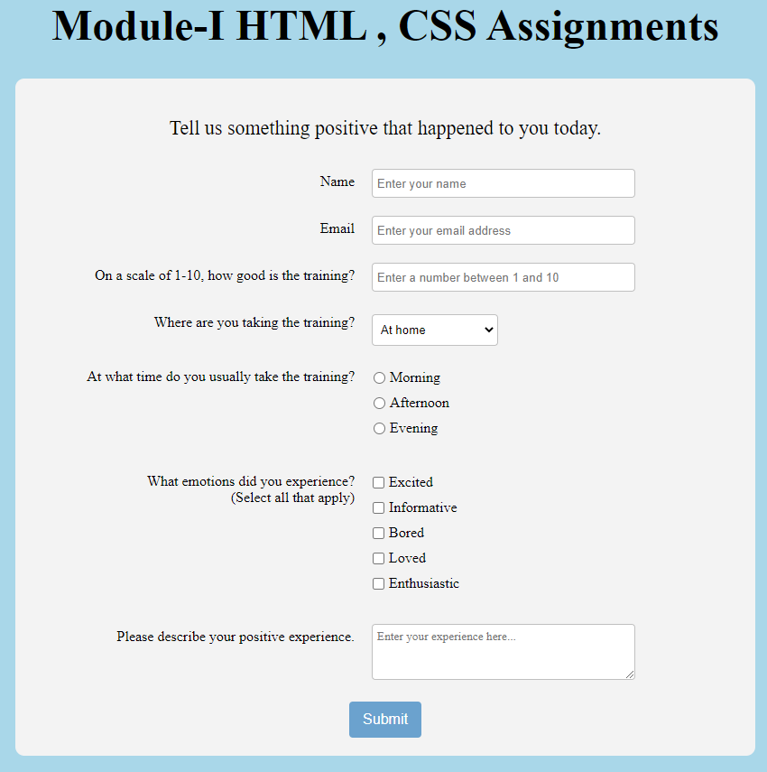

Task-ID 🡪 020506 , all images are given the zip file

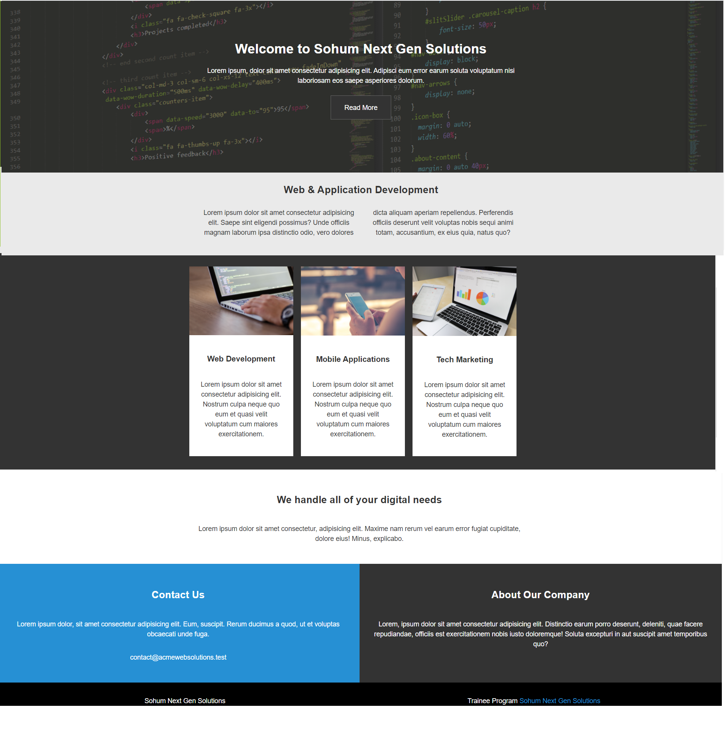

Below is the responsive view

768 X 1024 503 X 3658

|  |  |
| --- | --- |
|  |  |

Task-ID 🡪 030506 , all images can be downloaded form the below sites

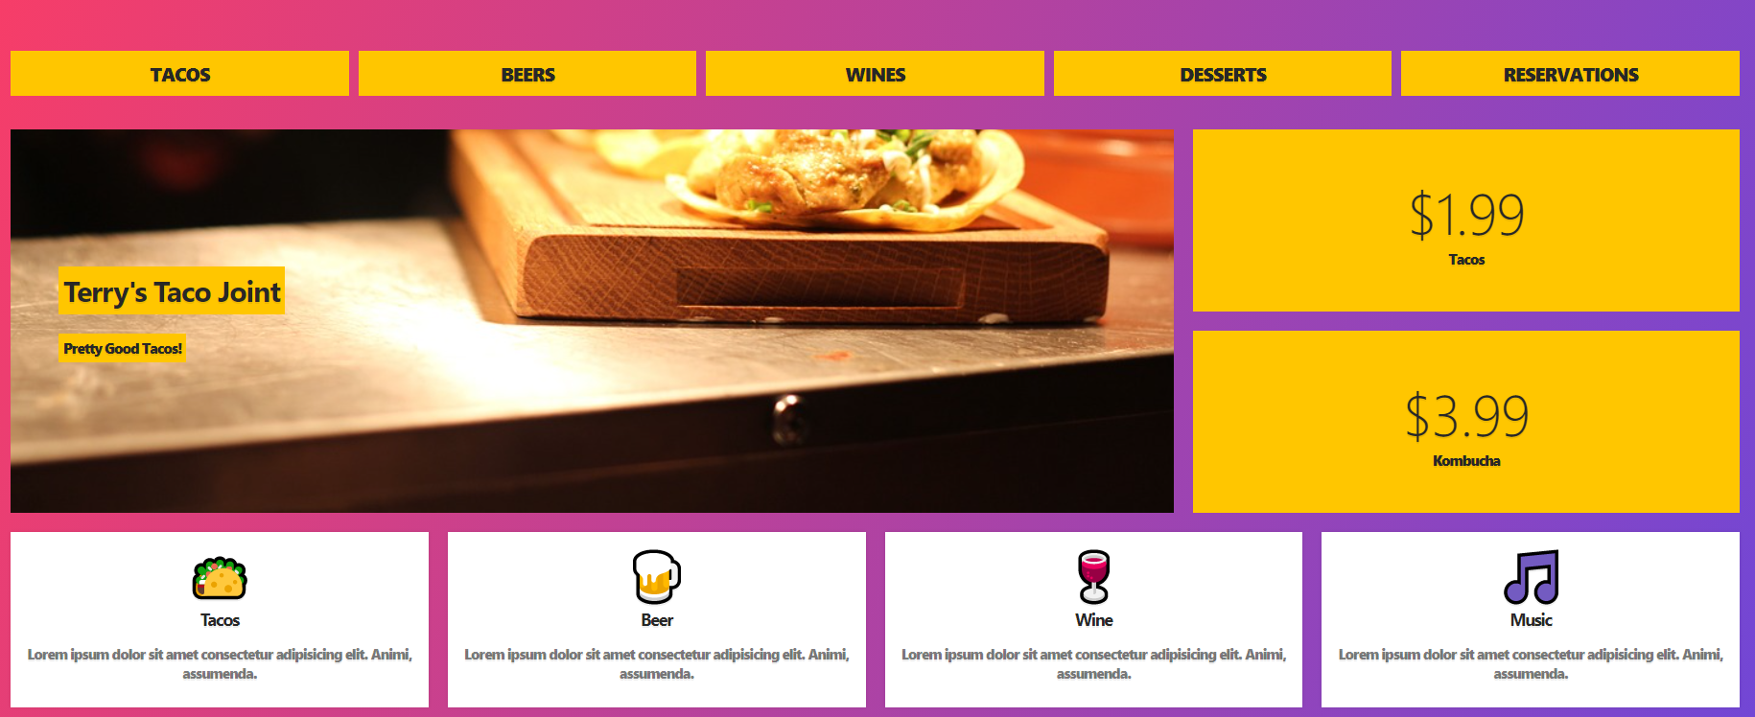

Responsive look

